`
Vulcan Activity Tracker
Weekly Report

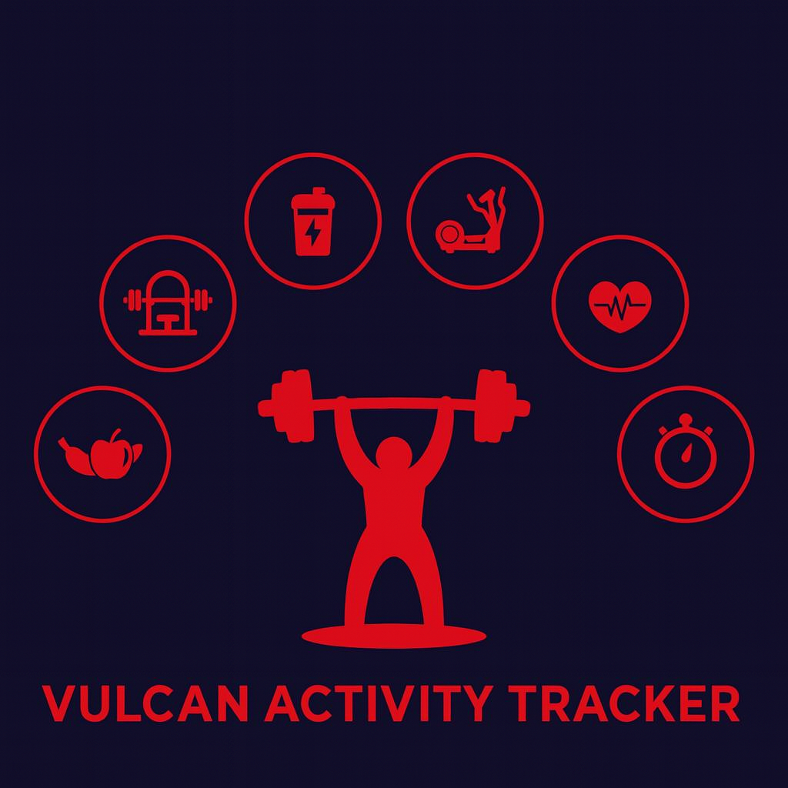

Week 6
Team Members:
Margo Bonal
John Gerega
Luke Ruffing

Professor: Dr. Weifeng Chen

Course: CMSC-4920-Senior Project II
School: Pennsylvania Western University

Table of Contents

Project: Vulcan Activity Tracker 2
Goals Accomplished: 2
Challenges Faced: 3
Solutions: 3
Team Progress: 3
Gantt Chart: 4
Week 7 Plan: 5
Member Contribution: 6

Project: Vulcan Activity Tracker
To complete the proposed goals in previous week’s report, our team followed a strict schedule of daily progress and communication. Our team had 4 main goals to complete, which included beginning the team page, implementing password requirements for the user, finalizing the friend feature, and beginning the challenges page. Additional goals included minor frontend fixes and the addition of the user email into the database. Since each goal needed time allocation for development and testing, we assigned each goal priority based on how they were connected to each other. Week 6 is a fundamental week as we near the end of February to move our project from initialization stages to fully under development. Significant effort will be designated in the upcoming weeks to ensure that the Vulcan Activity Tracker maintains well on schedule.

Goals Accomplished:
The first goal of week 6 was to finalize the friends feature of the Vulcan Activity Tracker. A user can now fully interact with friends’ public account information. Users can view top current activities and view clubs that their friends are members of. Additionally, users can show feedback in two unique ways! They can like a friend’s account and individual activities. This adds an interactive feature while limiting negative interactions by limiting to just a positive like button not a dislike button. Since the Vulcan Activity Tracker is designed with students and campus life in mind, we want to promote and encourage this positive interaction, allowing student athletes to feel a community base. Additionally, the friend feature limits users to only be able to see public activities. This enables privacy for app users and encourages a wider audience of students that may not want to appear publicly.
The second goal for week 5 was implementing password requirements. Before, a user could get away with entering one character or one digit as a password. This is no longer the case. A user’s password must be at least 8 characters long and contain an uppercase letter, a lowercase letter, and a number. When the user selects the password field on the create account page, a list of the previously listed requirements will appear, with each requirement having an X next to it. As the user enters their unique password, the requirement will have a checkmark placed next to it when it has been satisfied. The user cannot submit a password until all requirements have been satisfied.
The third feature added this week was the addition of a user email. The addition of the email was crucial in case the user ever forgot their password. The user is prompted for their Penn West email when creating an account. The program checks to ensure that the email contains ‘@pennwest.edu’ when the user tries to create their account. The next steps on this will be to verify the user’s email and to make sure the user can receive a recovery email in the case that they forget their password.
One of the most important goals and final goal for this week was to begin the team pages.

Challenges Faced:
(Number aligns with its solution below)
- Challenge One was found in finalizing the friends feature. To maintain separate like counts for the Profile Like vs the Activity Like, the same logic could not be directly reused.
- Re
- While we successfully implemented an email field into the program, it is not doing what we would like it to do yet. We cannot yet send an email with a password recovery link or a verification link when the user first logs in. We are also storing the email with no encryption in the database, which will need to be fixed immediately. We look to fix these issues in week 7.

Solutions:

Team Progress:
Our team made good progress this week 6. Various frontend and backend bugs were identified and resolved. Week 6 transformed the Vulcan Activity Tracker from concept to actuality. Almost all main components have been initialized or are under development. As progress continues, our team is able to make modifications based on usability experience and what we feel makes the most sense with users in mind. Each team member provides valuable contributions in debugging, development, and brainstorming. While we feel that we are currently on track with our Gantt chart, some components are not at the status we would like them to be at. For example, our team proposed in previous reports to be further along with the Teams, Maps, and Challenges Pages. While these features have been rearranged on the schedule to allow for debugging and completion of initial processes, we need to focus development on these attributes very soon. Another component for upcoming development is the initial research on hosting and launching our platform. Conversions from local databases to cloud-hosted data storage will also need to be researched. The following Gantt Chart image shows the current progress of the Vulcan Activity Tracker timeline.

Gantt Chart:
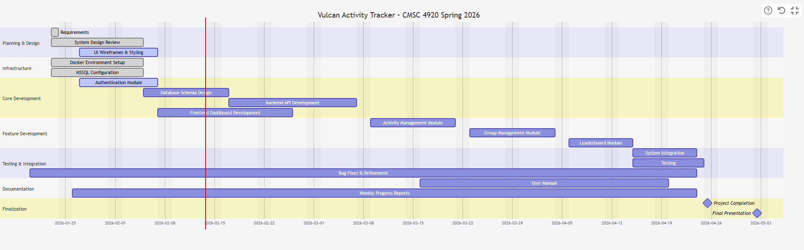

Week 7 Plan:
During week 7, our team proposes to allot time to check current programming progress against last semester’s documentation. This is to ensure that our goals are aligned with previous proposals and requirements are being met. Additionally, overall testing and debugging will commence to ensure that as we move towards later steps in development, we don’t have residual bugs and issues carrying along into the phase of development. We have identified that our team additionally needs to hold a meeting for initial impressions and testing with users outside of our development team. These beta testers were previously chosen last semester through documentation, and they will be reached out to participate in this scheduled team meeting. We propose that week 7 will be a productive week to move our project a step closer to the end goal!

Member Contribution:

Team Members
Margo Bonal: | - Team meetings, Week 6 Report & Slides, complete Friends feature
John Gerega: | - Team meetings, Week 6 Report & Slides, Email addition, password requirements, teams page
Luke Ruffing: | - Team meeting, Week 6 Report & Slides, Clubs page progress

